(Approx. 1173 words)

I Lost (Forgot!) my New Windows 10 Admin user password
By Art Gresham, Editor, UCHUG Drive Light
www.uchug.org
1editor101 (at) uchug.org

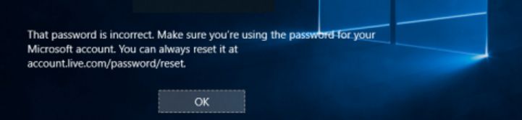
So yes, I upgraded a computer to Windows 10. On purpose. That was several weeks ago. But now I have forgotten what the password for that administrator, named “Admin” was set to. And since it is a local account (I have no use for creating a Microsoft Hotmail Account for every one of the computers I manage), I could not use the usual, published, methods for recovery using the Password Reset Tool for Microsoft Live Accounts.

I tried all my usual, possible and variations of passwords. No luck of course. This would call for the brute force method of recovery. Now I do have a log-in on the computer, as a non-administrator user. And there were no files or programs installed as that new administrator that had to be recovered. But I could not install/ uninstall, or do the normal set-up things that I need to do to put it in use again. I had to either get access by password, or create an entirely new administrator, which was a perfectly acceptable option for this situation.

After much searching, trying various easy (“Easy?”) fixes, I gave up. For a several weeks. Then in frustration I made more searches. Lots of fixes to be had, if I wanted to pay $17 or $35 for a 5 minute fix that is 'guaranteed to be easy and fast'. Pass.

More searching and I found a method that recommended making a couple of simple changes to some file names, and editing, done from a command box. Easy. Except it requires access beyond the normal login as a non-administrator. The file changes needed require administrator privilege, or to be accessed outside of a normal Windows boot up.

The method published would have you use the Windows distribution disk to go in a particular way, open the command box, do those commands and be back in business. Only one problem. Obviously I do not have a Windows 10 distribution disk. If I had that I would have been back in it long ago. What I needed was a way to access those files.

Many of us know that one way to have direct access to your hard drive files is to boot with another CD/DVD or Flash Drive, with another operating system. One which does not adhere to the file locks enforced by a Microsoft boot up. Since I run Linux Mint on all my home computers, and have the install on a thumb drive, and I have done several boots with other computers I knew this might hold the answer.

1. The first step was to get into the menu that selects startup boot process. That will be different for each manufacturer, but usually involves pressing a key during the early startup process, something like F11, or escape, or F8. Check with your manufacturer's model instructions, or just watch the screen as it starts and try to catch that quick message as it passes by. You may need a couple tries to succeed.

Once I was able to boot from my Linux thumb drive I used the instructions given from the original solution, performed the steps needed, rebooted into Windows 10, performed a couple more steps, this time in the Windows command box. I now have a fully normal operating Windows 10 system.

So what is the magic? The original article I based this on is here:
http://www.howtogeek.com/222262/how-to-reset-your-forgotten-password-in-windows-10/

But since I do not have the needed disk as described in the article, I skipped down to the section of that article which begins:

Create a New User to Save Account Files
If none of this works, there’s another measure you can take which will (in a very roundabout way), allow you to regain access to your computer.

2. So instead of following the bootup instructions using the Windows disk, I booted with Linux.

The instructions then have you use the Windows command box to do the following two commands:

move d:\windows\system32\utilman.exe d:\windows\system32\utilman.exe.bak
copy d:\windows\system32\cmd.exe d:\windows\system32\utilman.exe

3. Basically, rename the program file utilman.exe to have the dot bak extension, making room for a new file of the same name. Then replace it with a copy of the cmd.exe file, renamed to utilman.exe.

So in my Linux file manager I simply did the same things. Rename, Copy, Rename.

4. That was done. Next I removed the Linux boot thumb drive and restarted, allowing Windows to start normally. This brought up the normal Windows 10 screen, and ready to log in in as the non-administrator user. No problem.
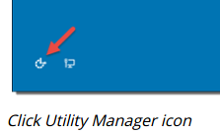
Here is where it can get a little sticky. You need to run that program (formerly known as utilman) from the login window. It may not appear on your initial login screen so you may have to start a log in as another user in order to make it present itself at the bottom of the screen. And the popup help message will not say it is utilman, but rather something about setting up windows. Trust me. Just click it.

5. Since we replaced the Utility Manager with the cmd.exe, a command prompt window should open now. Don’t worry about the error message.

You can now do one of two things. Either create an entirely new Admin account. OR change the password on the existing one. Since there was nothing to be lost by creating a new one I used that method. I have not tried the rename option which I will show at the end as step 7.

6. You can now add a new user with the command below. We also have to add the user to the administrator group so that we regain full control of our Windows installation. Replace <username> with the account name of your choice. Note that the account name must not exist on this Windows installation. (Don’t let the Windows 10 screen saver distract you.)

net user <username> /add
net localgroup administrators <username> /add

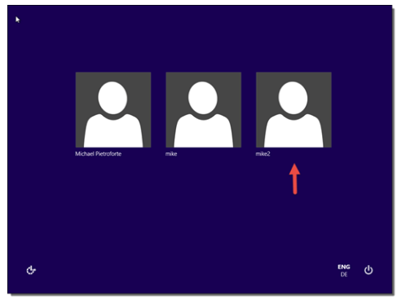

Click the screen (get out of the command window) to make the sign-in page appear again. Your new account should show up, and you can sign in without a password.

7. A shorter way to reset the password of a local account is to replace the first command in step 6 with the following command. (In this case, you don’t need to create a new user.)

net user <username> <password>

Now you can do all the normal things you may want to do, like change the password, after you write it on a sticky note!

Finally, remember to go back and delete that fake utilman.exe, and restore the name of the old one, if you ever want to get into those functions again. (using the Linux boot again)

My thanks to Michael Pietroforte for his article at (and credit for his images)
https://4sysops.com/archives/reset-a-windows-10-password/

as well as to Chris Stobing for his article at How-To Geek (credit for his login screen image)
http://www.howtogeek.com/222262/how-to-reset-your-forgotten-password-in-windows-10/

Please read their articles for more tips and instructions.

